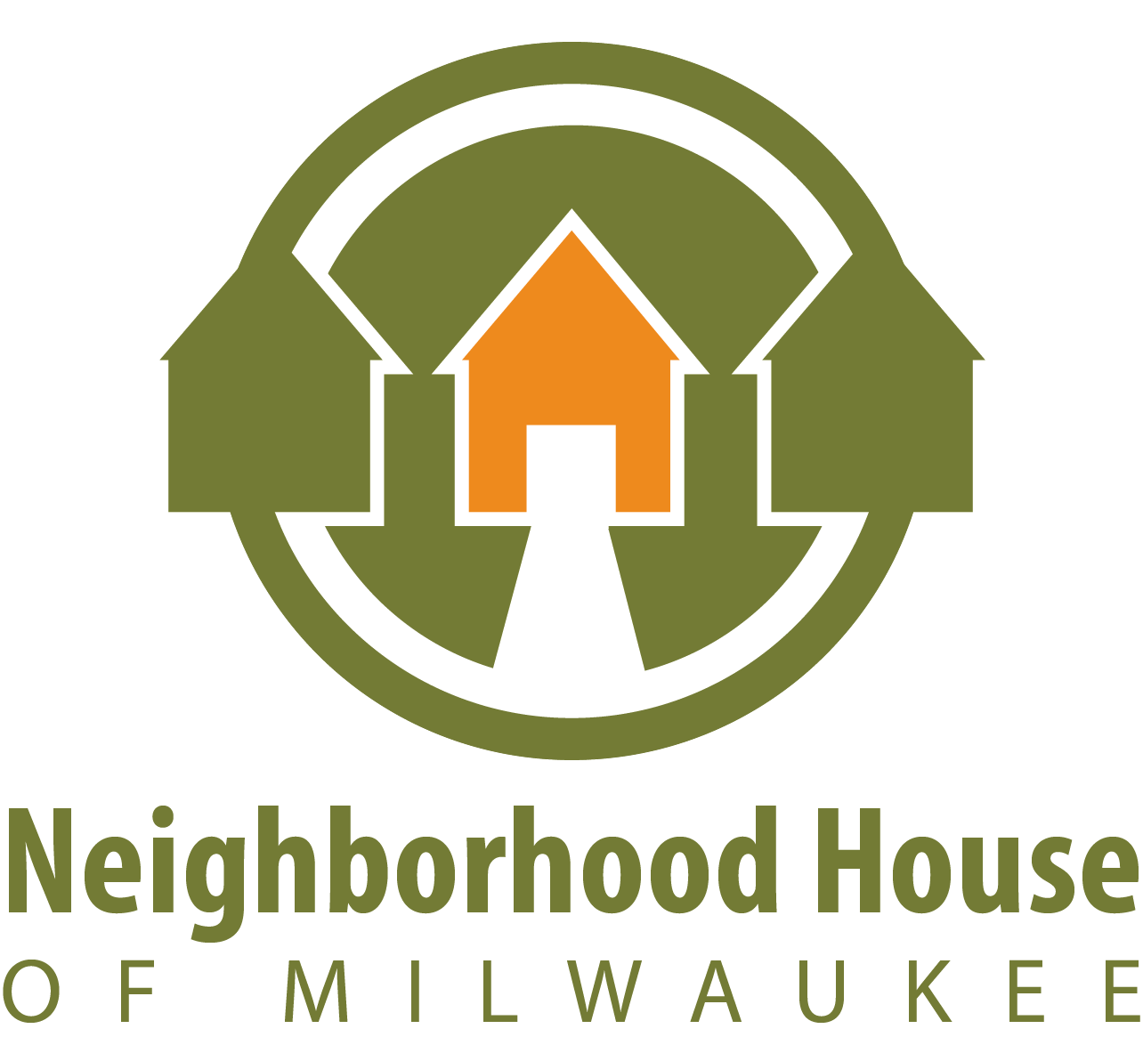

Development Intern

Sept. 5, 2018 - December 2018

Unpaid, 10 - 15 Hours/Week
Overview:
The Development Intern will work closely with and under the Development Director and Development Specialist in the ongoing work of reaching Neighborhood House of Milwaukee’s annual fundraising goals. Interns will support multiple aspects of development and marketing work, and in the process they will gain substantial hands-on experience in the nonprofit sector.

The below responsibilities are relevant day-to-day, but an overall willingness to learn about the nonprofit sphere through various meetings, events etc. is essential. The Development Intern will also be invited to learn about the various aspects of running a nonprofit through open communication and relationships with multiple departments.

Incoming college Sophomores or Juniors from a variety of majors are encouraged to apply. Intern would start September 5th, 2018, and end December 2018 (to be extended if mutually desired). Internship is unpaid and requires a 10-15 hours/week commitment, with flexible scheduling that puts intern’s academics first. If interested, please email resume and cover letter to Siena Morrissey, Development Specialist, at smorrissey@nh-milw.org.

Responsibilities to include:
Marketing
- Taking, organizing, and minimally editing photos of programs/participants.
- Gathering information in order to write short articles to be featured in our monthly newsletters and on social media platforms.
- Posting engaging and relevant content on social media platforms; tracking follower interactions with such posts.
- Utilizing Canva and Adobe InDesign to create flyers, brochures, and other marketing materials (no experience with these programs required, but a plus).
- Utilizing ConstantContact to send out emails and monthly newsletters to our constituents (no experience with this programs required, but a plus).
- Other miscellaneous duties as assigned.
Development
- Maintaining donor and grant databases and files, including logging donations, generating and sending donor acknowledgements, logging donor appreciation efforts, and organizing gift receipts.
- Supporting the creation and dissemination of Neighborhood House's Annual Report, biannual appeals, and monthly newsletters.
- Assisting staff with grant application tracking and dissemination.
- Supporting special events (Annual Gala, Annual Golf Outing) through logistical work including creation of invitation lists, soliciting sponsors and auction items, communicating with venue and vendors etc.
- Other miscellaneous duties as assigned.

Requirements:
- Be an incoming college Sophomore or Junior.
- Be responsible, hard-working, flexible, detail-oriented, ethical, and committed to the mission of Neighborhood House of Milwaukee.
- Possess solid oral and written communication skills.
- Be skilled at a variety of computer skills, e.g., Microsoft Word, Excel.
- Be able to operate or open to learning standard office equipment (fax, photocopier, etc.).
- Be able to juggle and prioritize multiple tasks.
- An interest in a nonprofit career ‐ particularly development and fundraising - is a plus!

