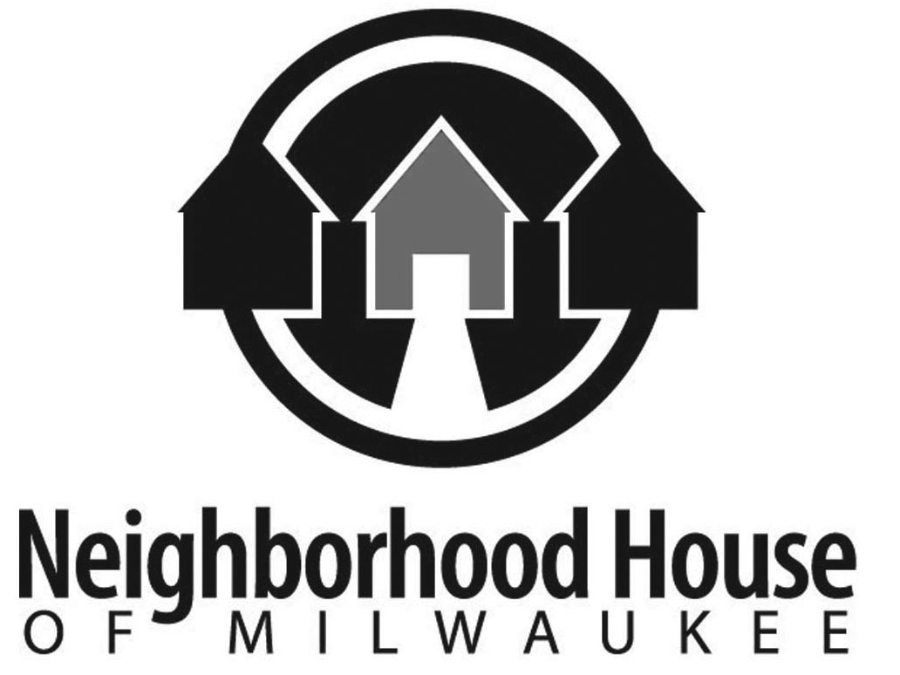
DEVELOPMENT DIRECTOR OPPORTUNITY
NEIGHBORHOOD HOUSE OF MILWAUKEE, INC.

Position: Director of Development Status: Full time, Exempt, Salaried Position

JOB PURPOSE AND REPORTING STRUCTURE:
Working with the Executive Director and the Neighborhood House of Milwaukee (NH) Board of Directors, the Director of Development will provide strategic, creative, and effective leadership in maintaining and growing a comprehensive Fund Development Plan to meet NH’s budgetary requirements for both annual operating expenses and special projects, consistent with the mission and vision of Neighborhood House of Milwaukee.

This position acts as an ambassador for Neighborhood House of Milwaukee, with a goal of developing new funding sources and maintaining positive donor and community relationships. The position works closely with the Executive Director, senior management and the NH Board of Directors in order to implement planning for annual and long term fund development.

ESSENTIAL DUTIES AND RESPONSIBILITIES:
1. Work with the Neighborhood House Board of Directors and Executive Director to develop the Fund Development Plan, which will identify, implement, and evaluate the fundraising strategy for the agency. It will ensure that Neighborhood House’s annual and long-term budgetary goals will be met or exceeded on schedule. Plans must include detailed timelines and task plans to equip the agency to achieve measurable success with both foreseeable and unplanned opportunities. Effort will include maintaining a visual development outcomes tracking report which summarizes efforts for NH Board and stakeholders.

2. Develop and oversee all individual donor cultivation, relationship building, solicitation and stewardship cycles. This includes sustaining the direction of a major gifts and planned giving programs.

3. Oversee all corporate and corporate foundation relationships, solicitations, volunteer support and recognition. This includes the oversight of two successful annual events, a fall gala and a spring golf outing.

4. Research and identify new individual and corporate funding sources.

5. Develop a Marketing and Public Relations strategy for Neighborhood House that helps create awareness and stewardship in the Milwaukee community, fosters relationships with media outlets, and supports the fundraising goals.

6. Direct and oversee the NH foundation, corporate, and governmental grants management efforts. Supervise management of the grants submission process, working with NH’s grant-writing consultant. The work includes the maintenance of grants calendar, funding priorities relevant to Neighborhood House, and reporting dates. Lead or participate in grantor site visits.

7. Manage and maintain the SAGE donor database and NH’s prospect tracking and management systems, including exploring options to migrate to a more preferred database.

8. Oversee the creation of the Annual Report, NH promotional publications, and annual appeals.

9. Support Neighborhood House’s overall relations with United Way and other federated giving campaigns.

10. Manage and mentor the NH Development Specialist, grant writer, development and teen outreach interns, and development event and project volunteers.

11. Serve as lead staff member to the NH Development and Marketing Committees.

12. Perform other development and communications duties as they arise.

EDUCATION AND EXPERIENCE:
• Bachelor’s Degree
• Five to seven years experience in fundraising including experience in soliciting major gifts, preferably with a non-profit organization.
• Experienced in managing staff and working with volunteers on fundraising.
• Experienced in managing successful special events
• Experienced in nonprofit marketing efforts, including print and social media and public/media relations.
• Ability to make direct solicitations of donors, knowledge of major foundations in southeastern Wisconsin, and a proven track record.

OTHER SKILLS AND ABILITIES:
• A high degree of initiative, flexibility, strong interpersonal skills, and excellent written and oral skills.
• Demonstrated ability to plan and effectively implement programs, manage multiple projects/multi-task and meet deadlines.
• Demonstrated awareness of sensitivity to/and competence in dealing with cultural and socioeconomic diversity of client population.
• Available to work flexible hours and weekends as needed.
• General working knowledge of the Milwaukee community.
• Experience and knowledge of social media such as Facebook, Instagram, and Twitter.
NEIGHBORHOOD HOUSE HISTORY AND PROGRAMS:
Established in 1945, the mission of Neighborhood House of Milwaukee (NH) is to inspire and connect by strengthening families and our community. One of Milwaukee’s oldest educational and social service agencies, NH will be celebrating our 75th anniversary in 2020. At NH, we believe a brighter future begins with a strong foundation. Our programming opens doors for people and empowers them to improve their lives and realize their dreams. We serve over 3,500 children and families each year. Our Early Head Start preschool program is YoungStar5 rated, amongst the best 6% in the area. Our International Learning Program, the largest refugee education effort in the State of Wisconsin, brings important refugee jobs, citizenship and ESL/ELL services to more than 500 individuals and their families annually. Finally, our 93-acre nature center and preserve in the central Kettle Moraine of Dodge County and our NH Garden Park are key parts of the strong environmental ethic that is part of our longstanding environmental education efforts.

Though we serve families from across the city, Neighborhood House focuses on the Near Westside neighborhoods, bounded by Hwy 41 on the west, I-43 on the east, Cherry Street on the north, and I-94 on the south. Our services are based in our home on Richardson Place, but we also work from multiple locations in the region.

NH is a financially-strong, fiscally-responsible agency with an annual budget of $2.3 million, having earned a 2018 Platinum Rating from GuideStar and successive years of clean audits. More info on our work is available at https://www.neighborhoodhousemke.org/

TO APPLY:
Send cover letter, bio/resume, and salary requirements to mdarrough@nh-milw.org

